Precision Interferometer (Rev 7/10/14)

Purpose:

1. Learn how to setup Michelson Interferometer.
2. Use it to measure wavelength of light (red laser).See note below.
3. Measure index of refraction of glass. Look up n for BK7 glass for red laser wavelength.
4. Measure index of refraction of air.
5. Repeat measurement of wavelength of light using Fabry-Perot setup. Understanding how the Fabry-Perot interferometer works will be useful in connection with the Zeeman experiment. Use the green laser if available.

The first part below discusses the equipment in general. Then the details of the 3 experiments you are to do are given. Do the experiments in the order listed above.

Note: There is an optional modification described on a page separate from these instructions that produces a larger image that makes it easier to count fringes.

Equipment

The OS-9255A Precision Interferometer includes the followingequipment:

• 5 kg Base with built-in micrometer

• Adjustable Mirror

• Movable Mirror

• Beam Splitter

• Compensator Plate

• (2) Component Holder

• Viewing Screen

• Lens, 18 mm Focal Length

• Diffuser

• Fitted Storage Case

**Additional Equipment Required –**

• Laser (OS-9171)

• Laser Bench (OS-9172)

NOTE:

The preceding equipment includes everything needed for basic Michelson interferometry. You can pro- duce clear fringes and make precise measurements

of the wavelength of your source. However, to perform the experiments in this manual, you will need additional components, such as the OS-9256A Interferometer Accessories or a comparable set of your own components.

The Precision Interferometer is available as a complete system. Please refer to your current PASCO catalog for details.

**Additional Equipment Recommended –**

The OS-9256A Interferometer Accessories includes:

• Rotating Pointer

• Vacuum Cell

• Component Holder

• Lens, 18 mm Focal Length

• Lens, 48 mm Focal Length

• Glass Plate

• (2) Polarizer

• Vacuum Pump with Gauge

NOTE:

The OS-9255A Fitted Case also provides storage for these accessory components.

**About Your Light Source**

We strongly recommend a laser for most introductory applications. A spectral light source can be used (see the Appendix), but that really comprises an experiment in and of itself for beginning students. A laser source is easy to use and produces bright, sharp fringes.

The OS-9171 Laser and OS-9172 Laser Alignment Bench are available from PASCO. However, any low power laser that operates in the visible range will work well. If you want to demonstrate the importance of polarization in interferometry, a non-polarized laser should be used. For easy alignment, the beam should be approximately 4 cm above the level of the bench top.

OS-9171 Laser

OS-9172

Laser Alignment

Bench

Adjustable

Mirror

Fitted Case

Lens

18 mm

Viewing

Screen

Beam

Splitter

Diffuser

(2) Component

Holder

Movable

Mirror

Compensator

Plate

**OS-9255A Precision Interferometer**

Lens

18 mm

Component

Holder

Base

Lens

48 mm

**OS-9256A Interferometer Accessories**

(2) Polarizer

Glass

Plate

Rotating

Pointer

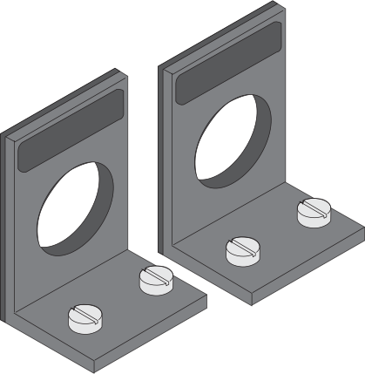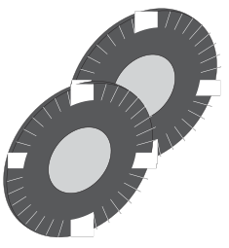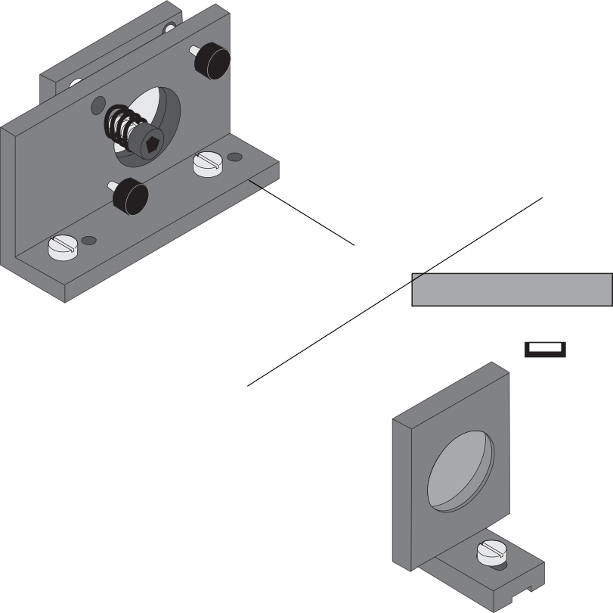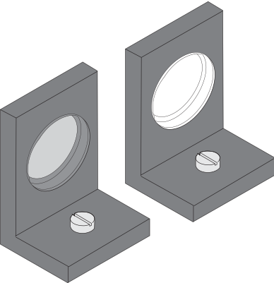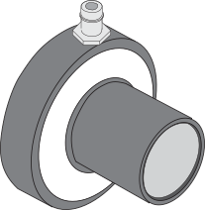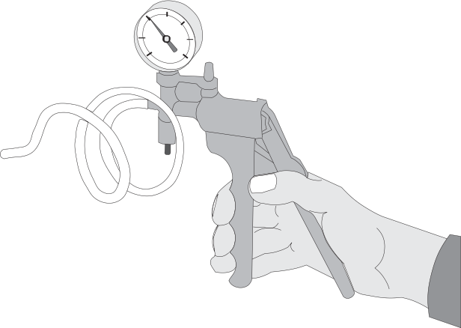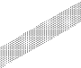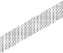

Vacuum Pump with Gauge

Vacuum Cell

Theory of Operation

**Interference Theory**

A beam of light can be modeled as a wave of oscillating electric and magnetic fields. When two or more beams of light meet in space, these fields add according to the principle of superposition. That is, at each point in space, the electric and magnetic fields are determined as the vector sum of the fields of the separate beams.

If each beam of light originates from a separate source, there is generally no fixed relationship between the electro- magnetic oscillations in the beams. At any instant in time there will be points in space where the fields add to produce a maximum field strength. However, the oscilla- tions of visible light are far faster than the human eye can apprehend. Since there is no fixed relationship between

the oscillations, a point at which there is a maximum at one instant may have a minimum at the next instant. The human eye averages these results and perceives a uniform intensity of light.

If the beams of light originate from the same source, there is generally some degree of correlation between the frequency and phase of the oscillations. At one point in space the light from the beams may be continually in phase. In this case, the combined field will always be a maximum and a bright spot will be seen. At another point the light from the beams may be continually out of phase and a minima, or dark spot, will be seen.

Thomas Young was one of the first to design a method for producing such an interference pattern. He allowed a

**The Michelson Interferometer**

In 1881, 78 years after Young introduced his two-slit experiment, A.A. Michelson designed and built an interfer- ometer using a similar principle. Originally Michelson designed his interferometer as a means to test for the existence of the ether, a hypothesized medium in which light propagated. Due in part to his efforts, the ether is no longer considered a viable hypothesis. But beyond this, Michelson’s interferometer has become a widely used instrument for measuring the wavelength of light, for using the wavelength of a known light source to measure extremely small distances, and for investigating optical media.

Figure 1 shows a diagram of a Michelson interferometer. The beam of light from the laser strikes the beam-splitter, which reflects 50% of the incident light and transmits the other 50%. The incident beam is therefore split into two beams; one beam is transmitted toward the movable mirror (M1), the other is reflected toward the fixed mirror (M2). Both mirrors reflect the light directly back toward the

beam-splitter. Half the light from M1 is reflected from the beam-splitter to the viewing screen and half the light from M2 is transmitted through the beam-splitter to the viewing screen.

Viewing Screen

single, narrow beam of light to fall on two narrow, closely spaced slits. Opposite the slits he placed a viewing screen. Where the light from the two slits struck the screen, a regular pattern of dark and bright bands appeared. When first performed, Young’s experiment offered important evidence for the wave nature of light.

Young’s slits can be used as a simple interferometer. If the spacing between the slits is known, the spacing of the maxima and minima can be used to determine the wave- length of the light. Conversely, if the wavelength of the light is known, the spacing of the slits could be determined

Lens

Laser

Beam

Splitter

Compensator

Plate

Movable Mirror

(M1)

Adjustable Mirror

(M2)

from the interference patterns.

**Figure 1. Michelson Interferometer**

In this way the original beam of light is split, and portions of the resulting beams are brought back together. Since the beams are from the same source, their phases are highly correlated. When a lens is placed between the laser source and the

beam-splitter, the light ray spreads out, and an

**Figure 2. Fringes**

NOTE: Using the Compensator

In Figure 1, notice that one beam passes through the glass of the beam-splitter only once, while the other beam passes through it three times. If a highly co- herent and monochromatic light source is used,

such as a laser, this is no problem. With other light sources this is a problem.

The difference in the effective path length of the separated beams is increased, thereby decreasing the coherence of the beams at the viewing

interference pattern of dark and bright rings, or fringes, is

seen on the viewing screen (Figure 2).

Since the two interfering beams of light were split from the same initial beam, they were initially in phase. Their relative phase when they meet at any point on the viewing screen, therefore, depends on the difference in the length

of their optical paths in reaching that point.

By moving M1, the path length of one of the beams can be varied. Since the beam traverses the path between M1 and the beam-splitter twice, moving M1 1/4 wavelength nearer the beam-splitter will reduce the optical path of that beam by 1/2 wavelength. The interference pattern will change; the radii of the maxima will be reduced so they now

occupy the position of the former minima. If M1 is moved an additional 1/4 wavelength closer to the beam-splitter,

the radii of the maxima will again be reduced so maxima and minima trade positions, but this new arrangement will be indistinguishable from the original pattern.

By slowly moving the mirror a measured distance dm, and counting m, the number of times the fringe pattern is restored to its original state, the wavelength of the light () can be calculated as:

screen. This will obscure the interference pattern.

A compensator is identical to the beam-splitter, but without the reflective coating. By inserting it in the beam path, as shown in Figure 1, both beams pass through the same thickness of glass, eliminating this problem.

**The Twyman-Green Interferometer**

The Twyman-Green Interferometer is a variation of the Michelson Interferometer that is used to test optical components. A lens can be tested by placing it in the beam path, so that only one of the interfering beams passes through the test lens (see Figure 3). Any irregularities in the lens can be detected in the resulting interference pattern. In particular, spherical aberration, coma, and astigmatism show up as specific variations in the fringe pattern.

= 2dm

●

m

Lens

Test

Lens

If the wavelength of the light is known, the same proce-

dure can be used to measure d .

m

**Figure 3. Twyman-Green Interferometer**

**The Fabry-Perot Interferometer**

In the Fabry-Perot Interferometer, two partial mirrors are aligned parallel to one another, forming a reflective cavity. Figure 4 shows two rays of light entering such a cavity and reflecting back and forth inside. At each reflection, part of the beam is transmitted, splitting each incident ray into a series of rays. Since the transmitted rays are all split from a single incident ray, they have a constant phase relationship (assuming a sufficiently coherent light source is used).

The phase relationship between the transmitted rays depends on the angle at which each ray enters the cavity and on the distance between the two mirrors. The result is a circular fringe pattern, similar to the Michelson pattern, but with fringes that are thinner, brighter, and more widely spaced. The sharpness of the Fabry-Perot fringes makes it a valuable tool in high-resolution spectrometry.

As with the Michelson Interferometer, as the movable

mirror is moved toward or away from the fixed mirror, the fringe pattern shifts. When the mirror movement is equal

to 1/2 of the wavelength of the light source, the new fringe pattern is identical to the original.

Partial Mirrors

Adjustable Movable

Viewing

Screen

**Figure 4. Fabry-Perot Interferometer**

Setup and Operation

**Laser Alignment**

• If you are using a PASCO Laser and Laser Alignment Bench, the setup and alignment procedure is as fol- lows.

• If you are using a different laser, the alignment proce- dure is similar. Adjust your laser so that the beam is approximately 4 cm above the table top. Then align the beam as in steps 4 and 5, below.

• If you are using a spectral light source instead of a laser, see Suggestions for Additional Experiments, near the end of the manual.

To set up and align your PASCO Laser:

1. Set the interferometer base on a lab table with the mi- crometer knob pointing toward you.

2. Position the laser alignment bench to the left of the base approximately perpendicular to the interferometer base and place the laser on the bench.

3. Secure the movable mirror in the recessed hole in the interferometer base.

4. Turn the laser on. Using the leveling screws on the la- ser bench, adjust its height until the laser beam is ap- proximately parallel with the top of the interferometer base and strikes the movable mirror in the center. (To check that the beam is parallel with the base, place a piece of paper in the beam path, with the edge of the paper flush against the base. Mark the height of the beam on the paper. Using the piece of paper, check that the beam height is the same at both ends of the bench.)

5. Adjust the X-Y position of the laser until the beam is reflected from the movable mirror right back into the laser aperture. This is most easily done by gently slid- ing the rear end of the laser transverse to the axis of the alignment bench, as shown in Figure 5.

You are now ready to set up the interferometer in any of its three modes of operation.

Laser beam

Component holder

Interferometer base

VIEWING SCREEN MICHELSON, TWYMAN-GREEN

OS-9255A

18 mm FL LENS

Viewing screen

VIEWING SCREEN MICHELSON, TWYMAN-GREEN

PRECISION INTERFEROME

Compensator

(optional)

Slide the rear of the laser laterally on the alignment bench until the beam is reflected

straight back into the

laser aperture.

ADJUSTABLE MIRROR MICHELSON, TWYMAN-GREEN

Movable mirror

Lens

ADJUSTABLE MIRROR MICHELSON, TWYMAN-GREEN

-5

0

5

10

15

20

25

15

20

25

Component holder

Beam splitter

Movable mirror

LENS

18 mm FL

Laser

Adjustable mirror

**Figure 5. Aligning the Laser**

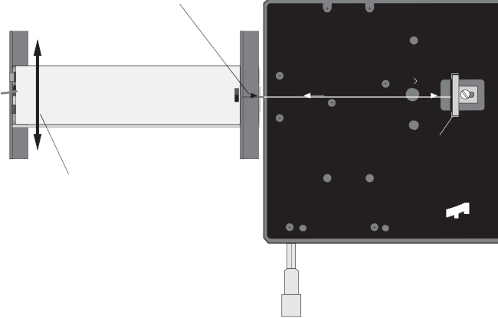

18mm FL

1 div =

NOTE:

-5

0

5

10

For ease of installation the placement of the individual components in the various modes is indicated on the label.

Thumbscrews



**Michelson Mode**

1. Align the laser and interferometer base as previously described. The laser beam should be approximately parallel with the top of the base, should strike the center of the movable mirror, and should be reflected directly back into the laser aperture.

2. Mount the adjustable mirror on the interferometer base.

Position one component holder in front of the laser. Place the other component holder opposite the adjust- able mirror and attach the viewing screen to its mag- netic backing. See Figure 6.

3. Position the beam-splitter at a 45 degree angle to the laser beam, within the crop marks, so that the beam is reflected to the fixed mirror. Adjust the angle of the beam-splitter as needed so that the reflected beam hits the fixed mirror near its center.

4. There should now be two sets of bright dots on the viewing screen; one set comes from the fixed mirror and the other comes from the movable mirror. Each

set of dots should include a bright dot with two or more

dots of lesser brightness (due to multiple reflections). Adjust the angle of the beam-splitter again until the two sets of dots are as close together as possible, then tighten the thumbscrew to secure the beam-splitter.

Micrometer knob

**Figure 6. Michelson Mode Setup**

5. Using the thumbscrews on the back of the adjustable mirror, adjust the mirror’s tilt until the two sets of dots on the viewing screen coincide.

6. The compensator is not needed for producing interfer- ence fringes when using a laser light source. However, if you wish to use the compensator, it mounts perpen- dicular to the beam-splitter, as shown.

7. Attach the 18 mm FL lens to the magnetic backing of the component holder in front of the laser, as shown, and adjust its position until the diverging beam is cen- tered on the beam-splitter. You should now see circu- lar fringes on the viewing screen. If not, carefully ad- just the tilt of the adjustable mirror until the fringes ap- pear.

8. If you have trouble obtaining fringes, see Trouble- Shooting at the end of this section.

**Twyman-Green Mode**

1. Set up the interferometer in the Michelson mode, as described above.

2. Remove the pointer from the rotational componet holder. (It is recommended to store the pointer, washer and thumbscrew in the storage case.) Place the compo- nent holder between the beam-splitter and the movable mirror (see Figure 7). It attaches magnetically. Mount a second 18 mm FL lens (L2) on its magnetic backing

and position it .

3. Remove the original lens (L1) from in front of the laser.

Observe the two sets of dots on the viewing screen— one set from the movable mirror and one set from the adjustable mirror. Adjust the position of L2 until both

sets of dots are the same size.

4. Adjust the tilt of the adjustable mirror until the two sets of dots coincide.

5. Replace lens L1 in front of the laser. Move the viewing screen so it's at least 12 inches from the edge of the interferometer base. Fringes should appear in the bright

disk of the viewing screen. Fine adjustments of L may be necessary to find the fringes. A piece of white paper or cardboard can be used in place of the viewing

1

**Fabry-Perot Mode**

1. Align the laser and interferometer base as described in Laser Alignment at the beginning of this section. The laser beam should be approximately parallel with the

top of the base, should strike the center of the movable

mirror, and should be reflected directly back into the laser aperture.

2. Mount the adjustable mirror where indicated on the in- terferometer base and one component holder in front of the movable mirror. See Figure 8.

3. Place the other component holder behind the movable mirror and attach the viewing screen to its magnetic backing. You should see several images of the laser beam on the viewing screen.

4. Using the thumbscrews, adjust the tilt of the adjustable mirror until there is only one bright dot on the screen.

5. Now mount the 18 mm FL lens on the front compo- nent holder. A clear sharp interference pattern should be visible on the viewing screen. If you use light with two component wavelengths, instead of a laser, two sets of fringes can be distinguished on the viewing screen.

screen. A 48 mm FL convex lens may also be used to magnify the projected image of the fringes.

Lens

18mm FL

Adjustable mirror Movable mirror

OS-9255A



Viewing screen

VIEWING SCREEN MICHELSON, TWYMAN-GREEN

PRECISION INTERFEROMETER

OS-9255A

VIEWING SCREEN MICHELSON, TWYMAN-GREEN

PRECISION INTERFEROMETER

Rotational

LENS FL

mm

18

OR HELSON

15

20

25

Lens

LENS FL

mm

18

18mm

Component holder

Component holder

TOR N

LSO

component holder

-5

0

5

10

ADJUSTABLE MIRROR MICHELSON, TWYMAN-GREEN

1 div = 1 MICRON

1 div = 1 MICRON

ADJUSTABLE MIRROR MICHELSON, TWYMAN-GREEN

-5

0

5

10

15

20

25

**Figure 8. Fabry-Perot Mode Setup**



**Figure 7. Twyman-Green Mode Setup**

Tips on Using the Interferometer

**Accurate Fringe-Counting**

The following techniques can help you make accurate measurements.

1. It's not necessary that your interference pattern be per- fectly symmetrical or sharp. As long as you can clearly distinguish the maxima and minima, you can make ac- curate measurements.

2. It's easy to lose track when counting fringes. The fol- lowing technique can help.

Center the interference pattern on the viewing screen using the thumb- screws on the back of the fixed mirror. Select a ref- erence line on the milli- meter scale and line it up with the boundary be-

5. The slip ring at the base of the micrometer knob adjusts the tension in the dial. Before making a measurement, be sure the tension is adjusted to give you the best pos- sible control over the mirror movement.

**Calibrating the Micrometer**

For even more accurate measurements of the mirror movement, you can use a laser to calibrate the micrometer. To do this, set up the interferometer in Michelson or

Fabry-Perot mode. Turn the micrometer knob as you count off at least 20 fringes. Carefully note the change in the micrometer reading, and record this value as d'. The actual mirror movement, d, is equal to N/2, where  is the known wavelength of the light (0.6328 µm for a

standard helium-neon laser) and N is the number of fringes that were counted. In future measurements, multiply your micrometer readings by d/d' for a more accurate measure- ment.

tween a maxima and a minima (see Figure 9). Move the micrometer dial

**Figure 9. Counting Fringes**

NOTE: You can also adjust the micrometer calibra- tion mechanically. The process is not difficult, but

for most accurate results, the above procedure is still

until the boundary between the next maximum and

minimum reaches the same position as the original boundary. (The fringe pattern should look the same as in the original position.) One fringe has gone by.

3. When turning the micrometer dial to count fringes, al- ways turn it one complete revolution before you start counting, then continue turning it in the same direction while counting. This will almost entirely eliminate er- rors due to backlash in the micrometer movement.

Backlash is a slight slippage that always occurs when you reverse the direction of motion in a mechanical in- strument. (Turning the micrometer dial clockwise moves the movable mirror toward the right. Turning the dial counter-clockwise moves the mirror toward the left.) The PASCO micrometer is designed to minimize backlash. However, by using the technique described above, you can practically eliminate all effects of back- lash in your measurements.

4. Always take several readings and average them for greater accuracy.

recommended. See the Maintenance section at the end of the manual for the mechanical calibration procedure.

**Demonstrations**

The PASCO interferometer is not designed for large demonstrations. However, for small demonstrations, you can use the 48 mm focal length lens (included in the Interferometer Accessories) to magnify the fringe pattern and project it onto a wall or screen. It is helpful to have a powerful laser for large projections.

**Using the Diffuser**

It's sometimes more convenient to view the interference pattern through the diffuser rather than on the viewing screen. Just place the diffuser where you would normally place the viewing screen, and look through it toward the interferometer.

**Sources of Experimental Error**

Backlash— Although PASCO's carefully designed mirror movement reduces backlash considerably, every mechani- cal system is susceptible to backlash. However, the effects of backlash can be practically eliminated by using proper technique when counting fringes (see item 3 under Accu- rate Fringe-Counting, on the previous page).

Mirror Travel— The amount of mirror movement per dial turn of the micrometer is constant to within 1.5%. Most of this error occurs at the extreme ends of the mirror’s total possible movement. For very accurate measurements, see Calibrating the Micrometer, above, and remember that the mirrors are flat to within 1/4 wavelength across their surface.

**Troubleshooting**

If you have trouble producing a clear set of interference fringes, consider the following possible sources of diffi- culty:

1. Warm up your Laser— Many lasers vary in intensity and/or polarization as they warm up. To eliminate any possible fringe or intensity variations, allow the laser to warm up prior to setting up an experiment. (The PASCO laser should warm up in about 1 hour.)

2. Check your Mirrors— The beam-splitter and movable mirror are carefully mounted in their brackets to remain perpendicular to the interferometer base when set up. If the brackets are bent slightly out of alignment, the resulting fringe patterns will be distorted somewhat. If they are significantly out of alignment, it may be impossible to obtain fringes.

3. Background Fringes— Reflections from the front and back surfaces of the mirrors and beam-splitter of- ten cause minor interference patterns in the back- ground of the main fringe pattern. These background patterns normally do not move when the mirror is moved, and have no impact on measurements made using the main interference pattern.

4. Convection Currents— If the fringe pattern ap- pears to wave or vibrate, check for air currents. Even a slight breeze can effect the fringes.

5. Vibration— Under normal conditions, the interferometer base and mirror mounts are stable enough to provide a vibration free setup. However, if the experiment table is vibrating sufficiently, it will effect the interference pattern.

IMPORTANT: If the movable mirror doesn't move when you turn the micrometer dial, see Micrometer Spacer Replacement in the Maintenance section at the end of this manual.

**Component Specifications**

Interferometer Mirrors— 3.175 cm in diameter;

0.635 + 0.012 cm thick; flat to 1/4 wavelength on both sides; coated on one side for 80% reflectance and 20% transmission.

Beam-Splitter— 3.175 cm in diameter; 0.635 + 0.012 cm thick; flat to 1/4 wavelength on both sides; coated on one side for 50% reflectance and 50% transmission.

Compensator— Identical to the beam-splitter, but uncoated.

Movable Mirror— movement is controlled by the micrometer that is built-into the interferometer base; turning the dial clockwise moves the mirror toward the right (looking from the micrometer side); 25 microns per micrometer dial revolution (±1% near center of move- ment); movement through full distance of travel is linear to within 1.5%.

IMPORTANT: Avoid touching all mirror surfaces. Minute scratches and dirt can impair the clarity of interference images. See the Maintenance section at the end of this manual for cleaning instructions.

Experiment 1: Introduction to Interferometry

**EQUIPMENT NEEDED:**

– Basic Interferometer (OS-9255A)

– Laser (OS-9171)

– Laser Alignment Bench (OS-9172)

– InterferometerAccessories(OS-9256A) Component Holder , (2) Calibrated Polarizers

Introduction

In general, an interferometer can be used in two ways. If the characteristics of the light source are accurately known (wavelength,

Lens

18mm FL

OS-9255A

Component holder

VIEWING SCREEN MICHELSON, TWYMAN-GREEN

Viewing screen

PREC/S/ON

/NTERFEROMETER

Movable

polarization, intensity), changes in the beam

LENS

18 mm FL

path can be introduced and the effects on the interference pattern can be analyzed. Experi- ments 2 and 3 are examples of this procedure. On the other hand, by introducing specific changes in the beam path, information can be obtained about the light source that is being used.

In this experiment, you'll use the interferometer to

Beam splitter

Adjustment

ADJUSTABLE MIRROR MICHELSON, TWYMAN-GREEN

Compensator

(optional)

Adjustable

-5

0

5

10

15

20

25

mirror

1 div = 1 MICRON

measure the wavelength of your light source. If

you have a pair of polarizers, you can also investigate the polarization of your source.

Thumbscrews

Micrometer knob

mirror

Procedure

Part I: Wavelength

Figure 1.1. Michelson Mode Setup



1. Align the laser and interferometer in the Michelson mode, so an interference pattern is clearly visible on your viewing screen. See Setup and Operation for instructions.

2. Adjust the micrometer knob to a medium reading (approximately 50 µm). In this position, the relationship be- tween the micrometer reading and the mirror movement is most nearly linear.

3. Turn the micrometer knob one full turn counterclockwise. Continue turning counterclockwise until the zero on the knob is aligned with the index mark. Record the micrometer reading.

➤ NOTE: When you reverse the direction in which you turn the micrometer knob, there is a small amount of give before the mirror begins to move. This is called mechanical backlash, and is present in all mechanical systems involving reversals in direction of movement. By beginning with a full counterclockwise turn, and then turning only counterclockwise when counting fringes, you can eliminate errors due to backlash.

4. Adjust the position of the viewing screen so that one of the marks on the millimeter scale is aligned with one of the fringes in your interference pattern. You will find it easier to count the fringes if the reference mark is one or two fringes out from the center of the pattern.

5. Rotate the micrometer knob slowly counterclockwise. Count the fringes as they pass your reference mark.

Continue until some predetermined number of fringes have passed your mark (count at least 20 fringes). As you finish your count, the fringes should be in the same position with respect to your reference mark as they were when you started to count. Record the final reading of the micrometer dial.

6. Record d

m

, the distance that the movable mirror moved toward the beam-splitter according to your

readings of the micrometer knob. Remember, each small division on the micrometer knob corre-

sponds to one µm (10-6 meters) of mirror movement.

7. Record N, the number of fringe transitions that you counted.

8. Repeat steps 3 through 7 several times, recording your results each time.

9. Go on to part two. If you have time afterward, try setting up the interferometer in Fabry-Perot mode and repeating steps 3 through 8.

Part II : Polarization (using the Calibrated Polarizer, part of OS-9256A Interferometer Accessories)

1. Place a polarizer between the laser and the beam-splitter. Try several polarization angles. How does this effect the brightness and clarity of the fringe pattern?

2. Remove that polarizer and place a polarizer in front of the fixed or movable mirror. Try several polarization angles. How does this effect the fringe pattern?

3. Now try two polarizers, one in front of the fixed mirror, and one in front of the movable mirror. First rotate one polarizer, then the other. Again, note the effects.

Analysis

Part I

1. For each trial, calculate the wavelength of the light ( = 2d

/N), then average your results. If you tried

m

the Fabry-Perot mode also, calculate the wavelength independently for that data. The same formula

applies.

Part II

1. From your observations in step 1 of the procedure, can you determine the polarization characteristics of your light source? Does it vary with time?

2. Do your observations from step 2 give you any more information about the polarization of your source?

3. From your observations in step 3, do cross-polarized beams interfere?

Questions

1. In the calculation to determine the value of  based on the micrometer movement, why was d

m

multiplied by two?

2. Why move the mirror through many fringe transitions instead of just one? Why take several measure- ments and average the results?

3. If you tried the Fabry-Perot mode, was your measured  the same? If not, can you speculate about possible reasons for the difference? Do you have more confidence in one value as opposed to the other?

4. If the wavelength of your light source is accurately known, compare your results with the known value. If there is a difference, to what do you attribute it?

5. When measuring mirror movement using the micrometer dial on the interferometer, what factors limit the accuracy of your measurement?

6. When measuring mirror movement by counting fringes using a light source of known wavelength, what factors might limit the accuracy of your measurement?

7. What role does polarization play in producing an interference pattern?

Experiment 2: The Index of Refraction of Air

**EQUIPMENT NEEDED:**

– Basic Interferometer (OS-9255A)

– Laser (OS-9171)

– Laser Alignment Bench (OS-9172)

– Interferometer Accessories (OS-9256A) Rotational pointer, Vacuum cell, Vacuum pump

Introduction

In the Michelson interferometer, the characteristics of the fringe pattern depend on the phase relationships between the two interfering beams. There are two ways to change the phase relationships. One way is to change the distance traveled by one or both beams (by moving the movable mirror, for example). Another way is to change the medium through which one or both of the beams pass. Either method will influence the interference pattern. In

2

Index of Refraction (n)

1

0

0 Gas Pressure (cm Hg)

**Figure 2.1. Index of Refraction versus Gas**

**Pressure**



PREC/S/ON

VIEWING SCREEN MICHELSON, TWYMAN-GREEN

this experiment you will use the second method to measure the index of refraction for air.

For light of a specific frequency, the wavelength  varies according to the formula:

● = **o**/**n**;

OS-9255A

/NTERFEROMETER

Vacuum Cell

Air Outlet

where 

LENS FL

mm

18

o

is the wavelength of the light in a vacuum, and

n is the index of refraction for the material in which the light is propagating. For reasonably low pressures, the index of refraction for a gas varies linearly with the gas pressure. Of course for a vacuum, where the pressure is zero, the index of refraction is exactly 1. A graph of index of refraction versus pressure for a gas is shown in Figure 2.1. By experimentally determining the slope, the index of refraction of air can be determined at various pressures.

Procedure

1 div = 1 MICRON

ADJUSTABLE MIRROR MICHELSON, TWYMAN-GREEN

-5

0

5

10

15

20

25

**Figure 2.2. Equipment Setup**

1. Align the laser and interferometer in the Michelson mode. See Setup and Operation.

2. Place the rotational pointer between the movable mirror and the beam-splitter (see Figure 2.2).

Attach the vacuum cell to its magnetic backing and push the air hose of the vacuum pump over the air outlet hole of the cell. Adjust the alignment of the fixed mirror as needed so the center of the interference pattern is clearly visible on the viewing screen. (The fringe pattern will be somewhat distorted by irregularities in the glass end-plates of the vacuum cell. This is not a problem.)

3. For accurate measurements, the end-plates of the vacuum cell must be perpendicular to the laser beam. Rotate the cell and observe the fringes. Based on your observations, how can you be sure that the vacuum cell is properly aligned?

4. Be sure that the air in the vacuum cell is at atmospheric pressure. If you are using the OS-8502 Hand- Held Vacuum Pump, this is accomplished by flipping the vacuum release toggle switch.

5. Record P , the initial reading on the vacuum pump gauge. Slowly pump out the air in the vacuum cell. As

i

you do this, count N, the number of fringe transitions that occur. When you're done, record N and also

P , the final reading on the vacuum gauge. (Some people prefer to begin with the vacuum cell evacuated, then count fringes as they let the air slowly out. Use whichever method is easier for you.)

f

➤ NOTE: Most vacuum gauges measure pressure with respect to atmospheric pressure (i.e., 34 cm Hg means that the pressure is 34 cm Hg below atmospheric pressure, which is ~ 76 cm Hg). The actual pressure inside the cell is:

Analyzing Your Data

**P**absolute = **P**atmospheric – **P**gauge

As the laser beam passes back and forth between the beam-splitter and the movable mirror, it passes twice through the vacuum cell. Outside the cell the optical path lengths of the two interferometer beams do not change throughout the experiment. Inside the cell, however, the wavelength of the light gets longer as the pressure is reduced.

Suppose that originally the cell length, d, was 10 wavelengths long (of course, it's much longer). As you pump out the cell, the wavelength increases until, at some point, the cell is only 9-1/2 wavelengths long. Since the laser beam passes twice through the cell, the light now goes through one less oscillation within the cell. This has the same effect on the interference pattern as when the movable mirror is moved toward the beam-splitter by 1/2 wavelength. A single fringe transition will have occurred.

Originally there are N = 2d/ wavelengths of light within the cell (counting both passes of the laser

i i

beam). At the final pressure there are N = 2d/ wavelengths within the cell. The difference between

f f

these values, N – N , is just N, the number of fringes you counted as you evacuated the cell. Therefore:

i f

N = 2d/ - 2d/ .

i f

However,  =  /n and  =  /n ; where n and n are the initial and final values for the index of

i 0 i

f 0 f i f

refraction of the air inside the cell. Therefore N = 2d(n – n ) / ; so that n – n = N /2d. The slope of

the n vs pressure graph is therefore:

n i – n f

i f 0

Nλ 0

i f 0

Pi – Pf =

2d(Pi – Pf )

where P = the initial air pressure; P = the final air pressure; n = the index of refraction of air at pressure

i f i

P ; n = the index of refraction of air at pressure P ; N = the number of fringe transitions counted during

i f f

evacuation; 

0

= the wavelength of the laser light in vacuum (see your instructor);

d = the length of the vacuum cell (3.0 cm).

1. Calculate the slope of the n vs pressure graph for air.

2. On a separate piece of paper, draw the n vs pressure graph.

Questions

1. From your graph, what is n

, the index of refraction for air at a pressure of 1 atmosphere (76 cm Hg).

atm

2. In this experiment, a linear relationship between pressure and index of refraction was assumed. How might you test that assumption?

3. The index of refraction for a gas depends on temperature as well as pressure. Describe an experiment that would determine the temperature dependence of the index of refraction for air.

Experiment 3: The Index of Refraction of Glass

**EQUIPMENT NEEDED:**

– Basic Interferometer (OS-9255A)

– Laser (OS-9171)

– Laser Alignment Bench (OS-9172)

– Interferometer Accessories

Rotating Table, Glass Plate

Introduction

In Experiment 2, the index of refraction of air was measured by slowly varying the density of air along a fixed length of one beam path in the Michelson Interferometer. That method obviously won't work with a solid substance, such as glass. Therefore, in order to measure the index of refraction of glass, it's necessary to slowly vary the length of glass through which the interferometer beam passes. This experi- ment introduces a technique for making such a measurement.

ADJUSTABLE MIRROR MICHELSON, TWYMAN-GREEN

Procedure

1. Align the laser and interferometer in the Michelson

OS-9255A

LENS FL

mm

18

PREC/S/ON

VIEWING SCREEN MICHELSON, TWYMAN-GREEN

/NTERFEROMETER

Glass plate

OR N

SO

Rotational pointer

1 div = 1 MICRON

-5

0

5

10

15

20

25

Read Angle of Inclination on Degree Scale

mode. See Setup and Operation.



2. Place the rotating table between the beam-splitter

and movable mirror, perpendicular to the optical path.

**Figure 3.1. Equipment Setup**

➤ NOTE: if the movable mirror is too far forward, the rotating table won't fit. You may need to loosen the thumbscrew and slide the mirror farther back.

3. Mount the glass plate on the magnetic backing of the rotational pointer.

4. Position the pointer so that its “0” edge on the Vernier scale is lined up with the zero on the degree scale on the interferometer base.

5. Remove the lens from in front of the laser. Hold the viewing screen between the glass plate and the movable mirror. If there is one bright dot and some secondary dots on the viewing screen, adjust the angle of the rotating table until there is one bright dot. Then realign the pointer scale. The plate should now be perpendicular to the optical path.

6. Replace the viewing screen and the lens and make any minor adjustments that are necessary to get a clear set of fringes on the viewing screen.

7. Slowly rotate the table by moving the lever arm. Count the number of fringe transitions that occur as you rotate the table from 0 degrees to an angle  (at least 10 degrees).

Data Analysis

In principle, the method for calculating the index of refraction is relatively simple. The light passes through a greater length of glass as the plate is rotated. The general steps for measuring the index of refraction in such a case is as follows:

1. Determine the change in the path length of the light beam as the glass plate is rotated. Determine how much of the change in path length is through glass, d (), and how much is through air, d ().

g a

2. Relate the change in path length to your measured fringe transitions with the following equation:

2n ad a(θ) + 2n gd g(θ)

λ 0

where n

a

= the index of refraction of air (see Experiment 2), n

= the index of refraction of the glass

plate (as yet unknown), 

g

0

= the wavelength of your light source in vacuum, and N = the number of

fringe transitions that you counted.

Carrying out this analysis for the glass plate is rather complicated, so we'll leave you with the equation shown below for calculating the index of refraction based on your measurements. Nevertheless, we encourage you to attempt the analysis for yourself. It will greatly increase your understanding of the measurement and also of the complications inherent in the analysis.

(2t – Nλ 0 )(1 – cosθ)

2t(1 – cos θ) – N λ 0

where t = the thickness of the glass plate.

➤ NOTE: Our thanks to Prof. Ernest Henninger, DePauw University, for providing this equation from Light Principles and Measurements, by Monk, McGraw-Hill, 1937.

